
Profield Chat v2 User Guide
Revision History
Version | Author | Date | Remarks
1.0 | Suraj P | 26 Aug 202 | Created

Table of Contents
- Model Predicition 3

1.model PREDICTION
For predicting use model run the following command in terminal:
python yolo_image.py [-h] [--model MODEL]
[--classes CLASSES] [--image]

Here MODEL is the trained best modelweight (it is an h5 format file), CLASSES is location of all class names stored in a text file.
After running above command we need to specify the location of image. Enter the complete location in terminal.
For predicting multiple images separate the location using comma, for example:
‘test/image1.jpg,test/image2.jpg,………..’

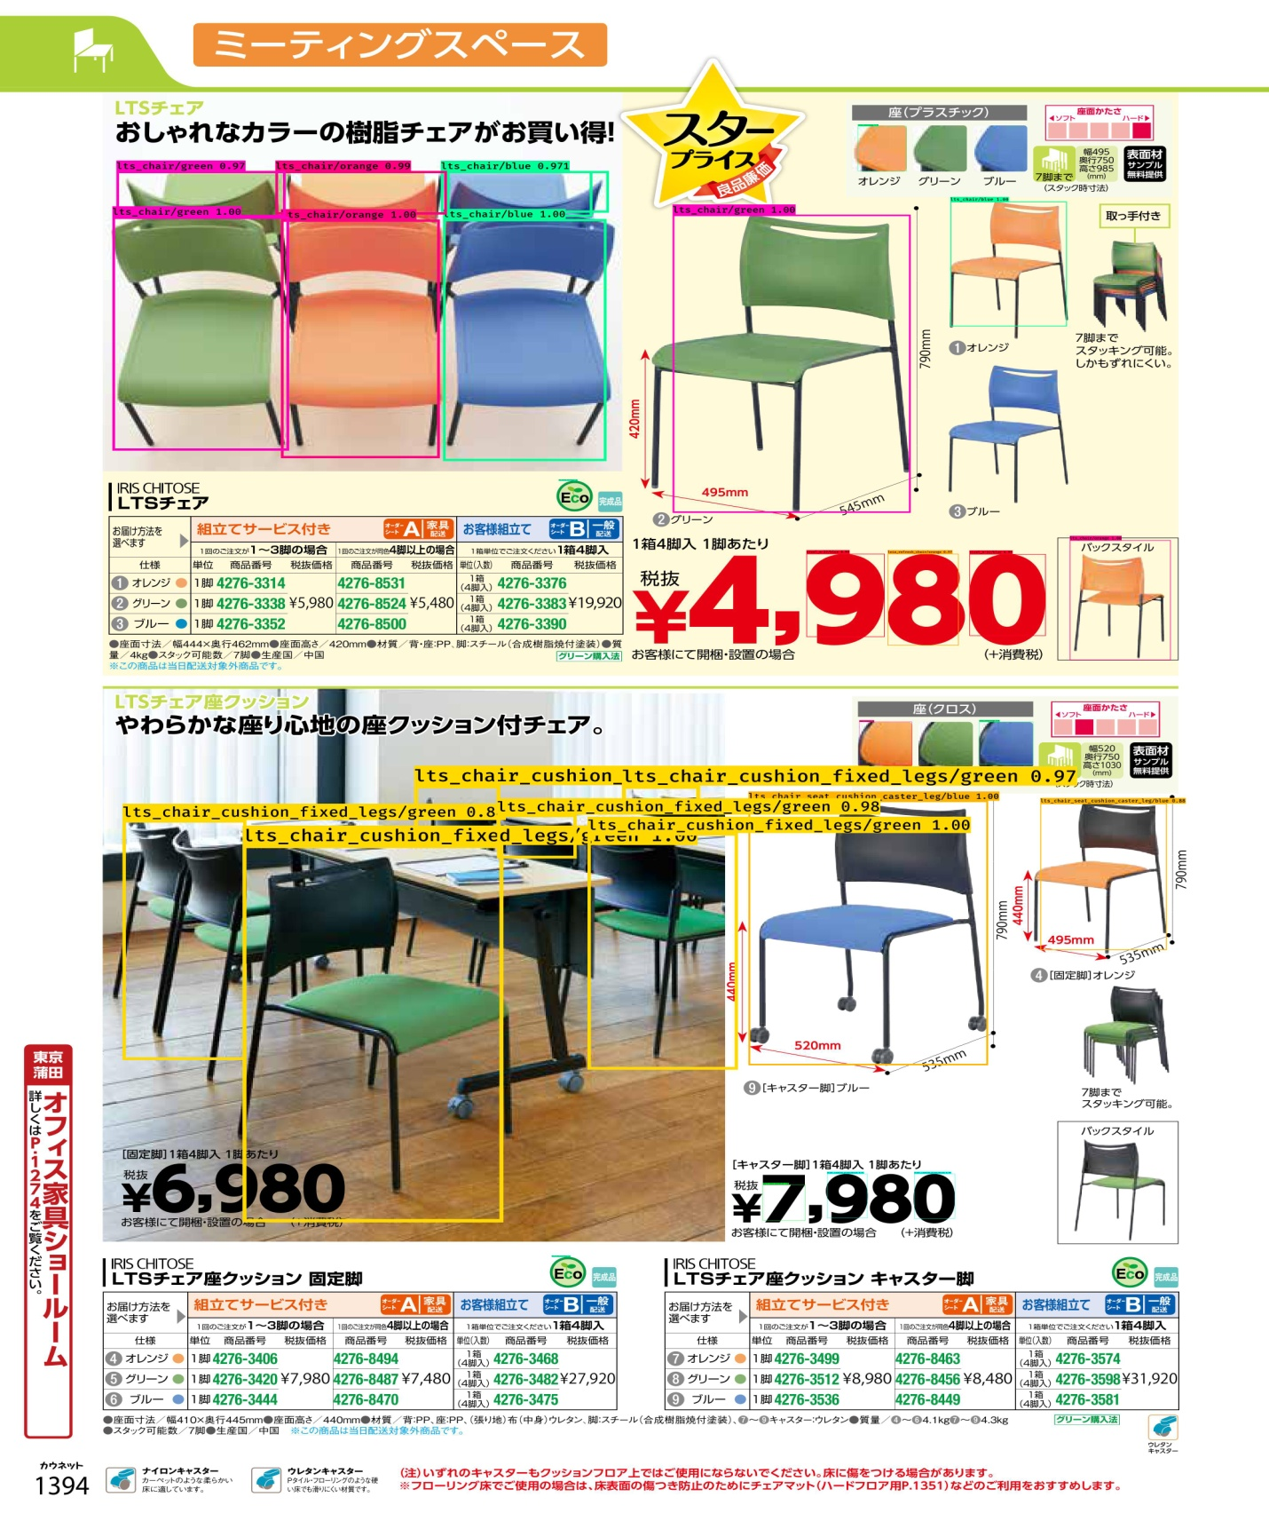
Figure 1 Samle of output file after prediction

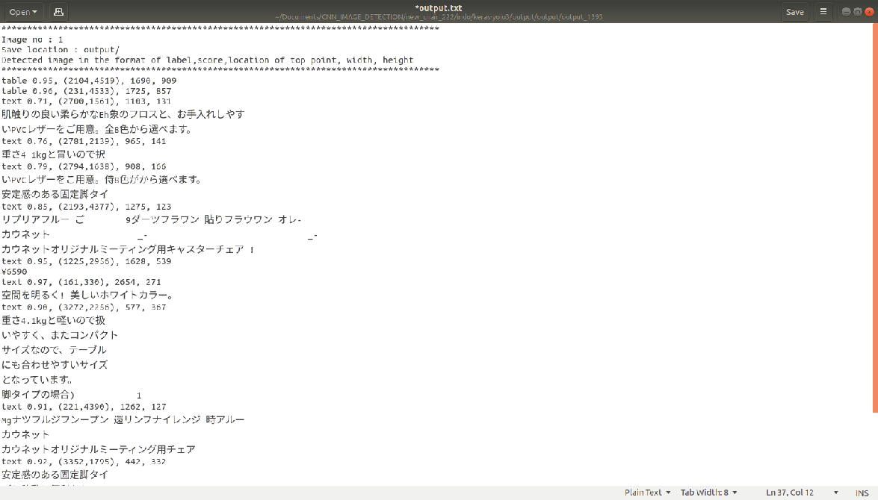
Figure 2 Sample of output text file saved

